“Two Rivers Plein Air 2024”
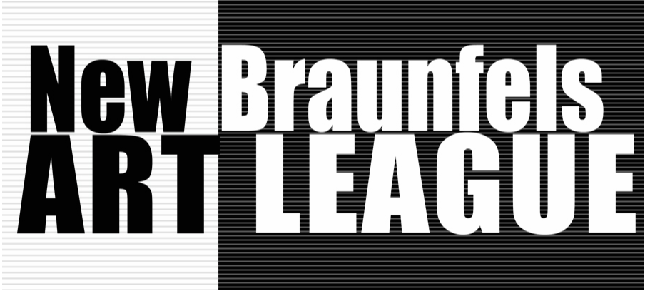
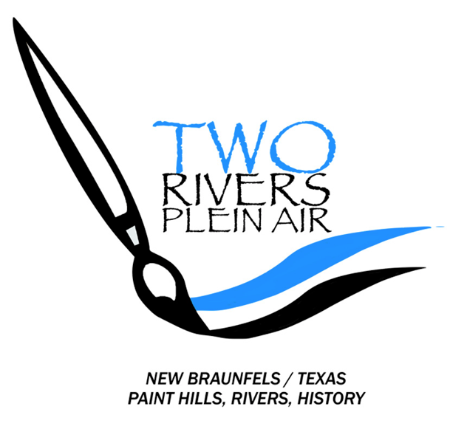
Artist Registration
“Two Rivers Plein Air” is a non-juried five-day plein air event. The $75 entry fee includes the Quick Draw Event with the Meet & Mingle opening reception. We will be accepting the first 35 artists, with 10 alternates on standby, who register and pay the entry fee.
The Meet & Mingle opening reception of appetizers, and non-alcoholic drinks, will be provided for the participating artists. If an artist wants to buy an additional food/drink ticket for a guest, the cost will be $15. This ticket will need to be purchased at the same time as when the entry fee is paid.
All Artists must provide the following to TwoRiversPleinAir@gmail.com for registration:
1. Contact Information (Specify TRPA 2024)
- NAME: ____________________________________________
- E-MAIL: ____________________________________________
- CELL PHONE: _________________________
- ADDRESS: ______________________________ CITY: ____________________________ STATE:_____ ZIP:________
2. Artist’s Biography (One Page)
3. Artist’s Photography (Head Shot)
************************************************
Then to complete your registration, please pay your entry fee of $75. This may be done in one of these two ways:
MAIL A CHECK TO: NBAL, PO Box 310325, New Braunfels, TX 78131-0325 (Specify TRPA 2024)
ENTRY FEE $75
EXTRA Guest ticket for MEET AND MINGLE $15
--- OR ---
PAY WITH YOUR PAYPAL ACCOUNT TO: nbaltreasurer@gmail.com (Specify TRPA 2024)
ENTRY FEE $80 …. Includes CONVENIENCE FEE for the use of PayPal
EXTRA Guest ticket for MEET AND MINGLE $15

*NO Cancellation Refund after August 1*
Mary K. Hammond
NBAL President/Event Chairman

