Still Life Oil Painting with Qiang Huang

3-day workshop November 11, 12 13 2022

$450/Member $485/Non-Member $100 Deposit

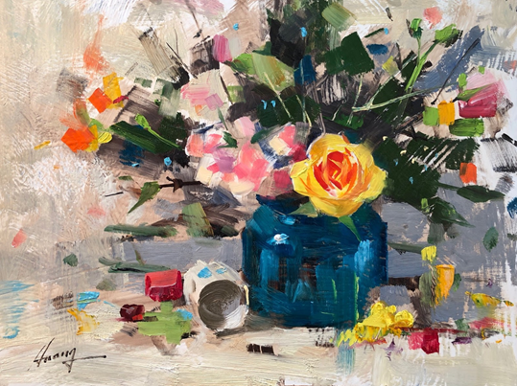

Qiang Huang's (pronounced Chong Wong) paintings are known for their remarkable accuracy and expressive brush strokes.

During the workshop Qiang will demonstrate his unique approach to painting still life giving tips on setting up a still life, using dramatic lighting, making bold and loose strokes, manipulating edges, adjusting values and mixing colors to create powerful and accurate representations on canvas.

Typically Qiang begins the workshop with a simple demo with fruit in which he will cover composition and his painting procedure while creating a painting. In the afternoon the students will begin their own paintings and he will give each of them individual attention according to his/her current skill level and their individual goals. The second day will be a paint along with Qiang. He will begin to demo a second still life featuring metal and glass textures but stop after the first step of his procedure. The students will then paint their first step. Then on to the second step and so on. The students will be able to watch the separate steps demonstrated and then follow along while he gives assistance at their easels. The third day he will paint a still life demo featuring flowers in the morning and the students will paint in the afternoon.

See more about Qiang Huang on his website at [www.qh-art.com](http://www.qh-art.com).

Make checks payable to NBAL and be sure to include which workshop you will be taking along with a phone number and email address.in the envelope with your check. Mail to: Barbara Blaschke, P.O. Box 3166, Canyon Lake, Texas 78133

For questions, email: barbarablaschke6@gmail.com or call mobile 830 513 3928.

For local accommodations check out: <https://www.playinnewbraunfels.com/stay>

Presented by New Braunfels Art League, 239 W. San Antonio St., New Braunfels, Texas