“QUICK DRAW 2024”
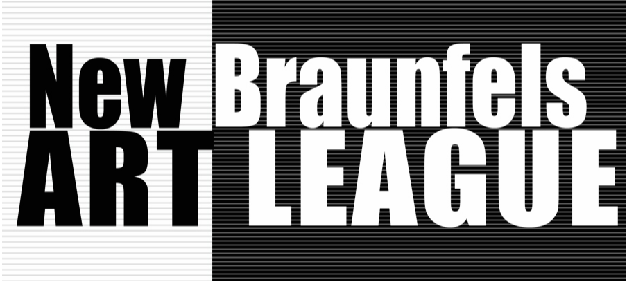
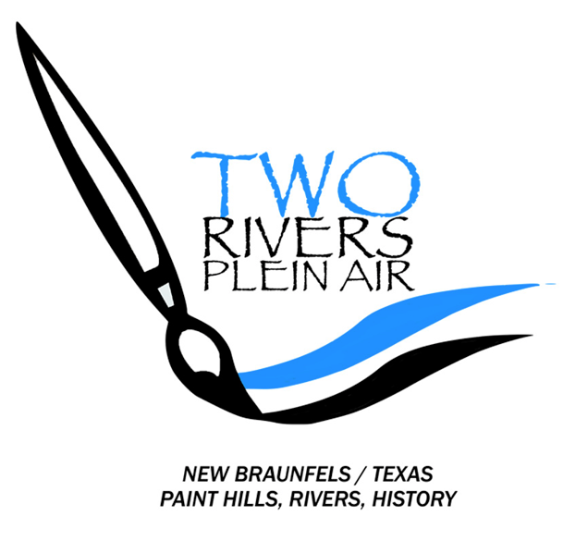
Artist Registration
Quick Draw Event is a one-day timed competition, includes the Meet & Mingle opening reception. It is open to all outside artists who register and pay a $30 entry fee for this one-day activity.
The Meet & Mingle opening reception of appetizers, and non-alcoholic drinks, will be provided for the participating artists. If an artist wants to buy an additional food/drink ticket for a guest, the cost will be $15. This ticket will need to be purchased at the same time as when the entry fee is paid.
All Artists must provide the following to TwoRiversPleinAir@gmail.com for registration:
Contact Information (Specify QD 2024)
- NAME: ____________________________________________
- E-MAIL: ____________________________________________
- CELL PHONE: _________________________
- ADDRESS: ______________________________ CITY: ____________________________ STATE:_____ ZIP:________

************************************************
Then to complete your registration, please pay your entry fee of $30. This may be done in one of these two ways:
MAIL A CHECK TO: NBAL, PO Box 310325, New Braunfels, TX 78131-0325 (Specify QD 2024)
ENTRY FEE $30
EXTRA Guest ticket for MEET AND MINGLE $15
--- OR ---
PAY WITH YOUR PAYPAL ACCOUNT TO: nbaltreasurer@gmail.com (Specify QD 2024)
ENTRY FEE $35…. Includes CONVENIENCE FEE for the use of PayPal
EXTRA Guest ticket for MEET AND MINGLE $15
*NO Cancellation Refund after August 1*

Mary K. Hammond
NBAL President/Event Chairman

